Winter Outlook: Return of El Niño?

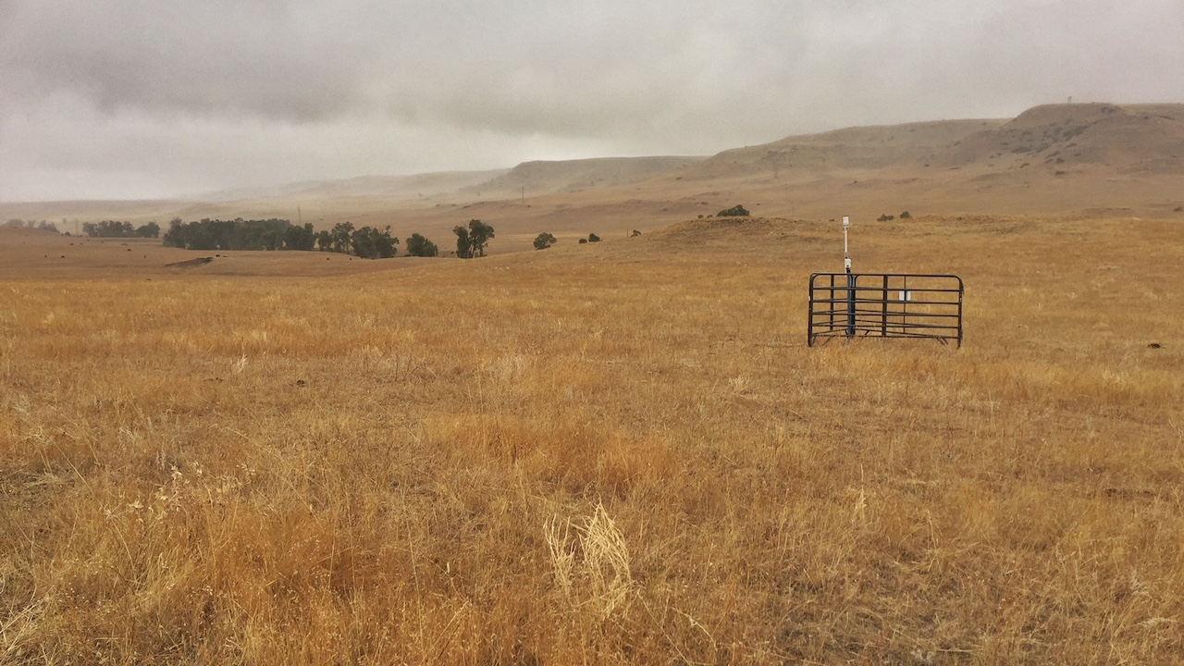

A new Montana Mesonet station near Absarokee, MT. Photo: Kevin Hyde.

## 

### El Niño Outlook

Winter weather in Montana is heavily influenced by the El Niño Southern Oscillation (ENSO)—natural seasonal fluctuations in sea surface temperature of the Pacific ocean near the equator. ENSO affects the position of the jet stream over North America. When the ocean is warmer than normal, Montana tends to experience warm, dry winters; we call this an “El Niño” event. When the ocean is cooler than normal, Montana tends to experience cool, wet winters; this is called a “La Niña”. However, in the past there *have* been El Niño winters that were cooler or wetter than normal, and La Niña winters that were warmer and drier!

According to NOAA, there is a 65–70% chance of El Niño conditions arriving this coming winter. These maps show what an average El Niño December–February looks like relative to normal. Keep an eye on the NOAA ENSO outlook (<https://www.climate.gov/enso>) for the latest ENSO conditions and predictions as we head in to winter.

El Niño winters are on average warmer than normal winters across Montana, especially as you move towards northeastern Montana. They are also drier than normal years, but only slightly, and only in north-central Montana; the southwestern and far easters portions of the state actually experience slightly *wetter* conditions in El Niño years.

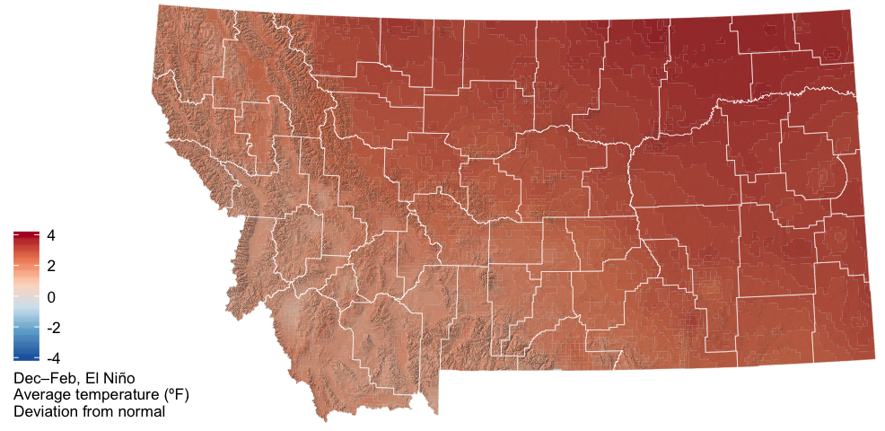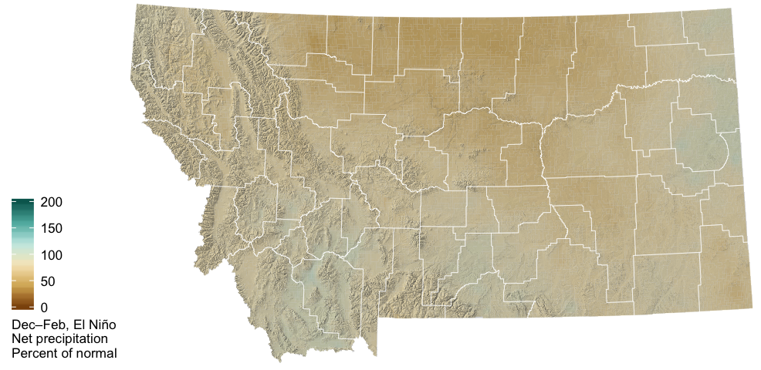

These graphs of annual statewide ENSO patterns show how Montana is affected by El Niño. The solid lines represent the average conditions in each of El Niño (red), La Niña (blue), and ENSO Neutral (gray) conditions. The dashed lines represent the lower and upper extremes of each of those patterns. For temperature, ENSO conditions only have a strong influence on Montana climate in the winter months; the red line (El Niño) is above the other lines, indicating warmer conditions on average in El Niño years. For precipitation, however, it is very difficult to distinguish the three lines. El Niño conditions lead to slightly drier winters, while La Niña conditions are indistinguishable from ENSO Neutral conditions.

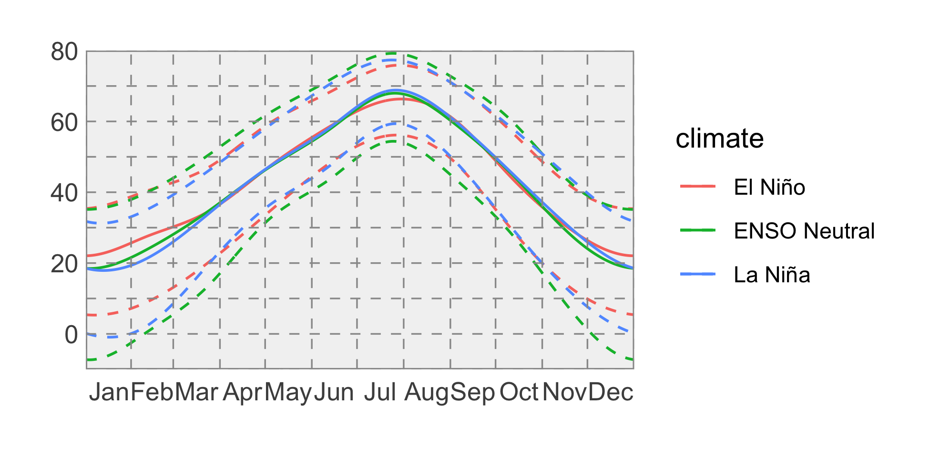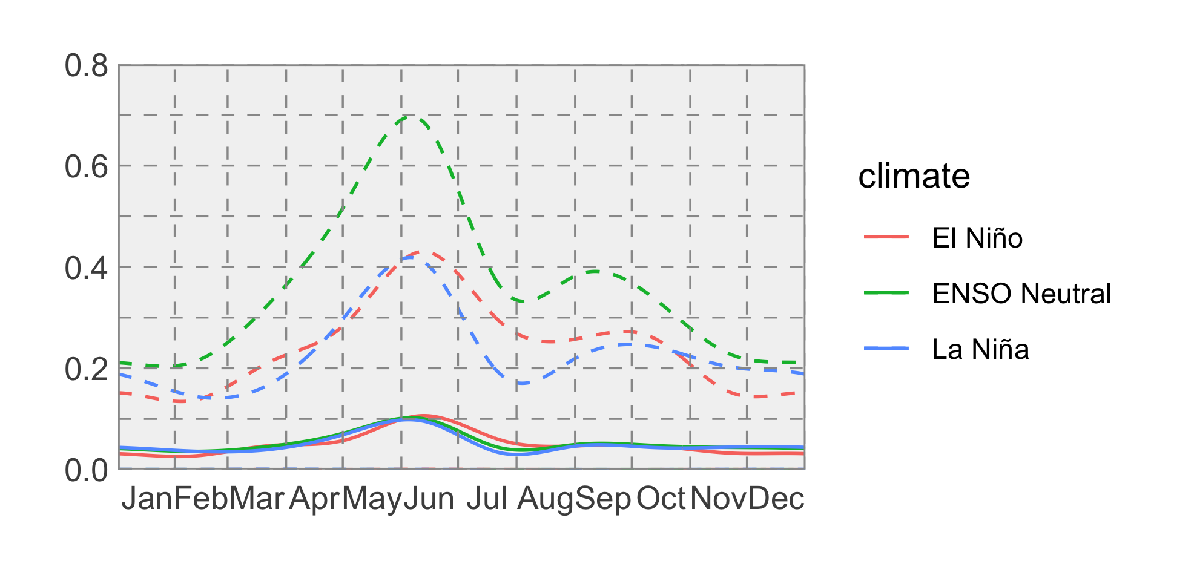

### Temperature

Because ENSO has such a strong influence on weather in North America, NOAA’s Climate Prediction Center (CPC) seasonal projections typically match the ENSO projections, especially in El Niño or La Niña years. Because of the high probability of there being an El Niño event beginning this winter, the CPC is projecting warmer conditions across Montana, with more certainty for the northwestern part of the state.

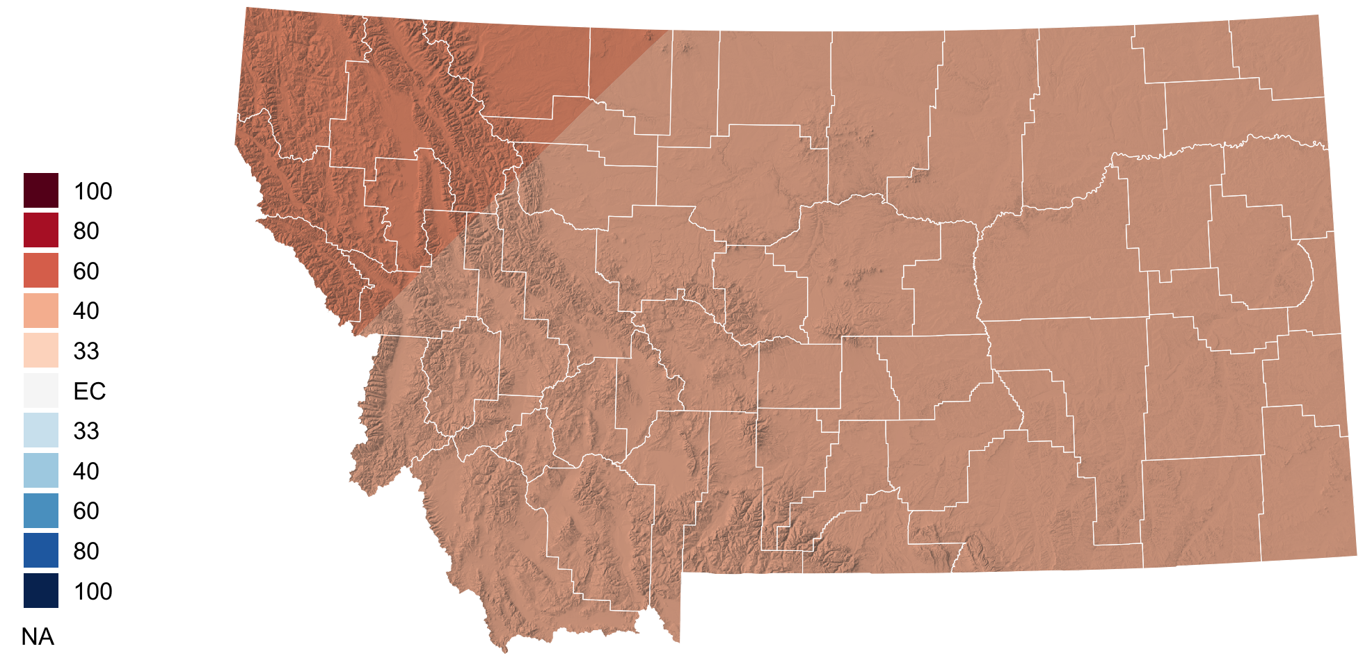

### Precipitation

The CPC is projecting lower than normal precipitation across Montana, with the exception of the southeastern part of the state where it is predicting near-normal conditions.

